# PROJECT DEVELOPMENT PHASE DELIVERY OF SPRINT-1

**FRONTEND USING(HTML/CSS/JAVASCRIPT) HOME PAGE**

<!DOCTYPE html>

<html lang="en">

<head>

<meta charset="UTF-8">

<title>Med Remainder</title>

<link rel="stylesheet" href="{{url_for('static', filename='css/home.css')}}">

<link rel="stylesheet" href="https://cdnjs.cloudflare.com/ajax/libs/font- awesome/6.2.0/css/all.min.css"

integrity="sha512- xh6O/CkQoPOWDdYTDqeRdPCVd1SpvCA9XXcUnZS2FmJNp1coAFzvtCN9BmamE+4aHK8yyUHUSCcJHg XloTyT2A=="

crossorigin="anonymous" referrerpolicy="no-referrer" />

</head>

<body>

<div class="full-page">

<div class="navbar">

<div>

<a href='website.html'>Med Remainder</a>

</div>

<nav>

<ul id='MenuItems'>

<li><button class='loginbtn' onclick="document.getElementById('login-form').style.display='block'"

style="width:auto;">Login</button></li>

</ul>

</nav>

</div>

<center><p style="color: aliceblue;">{{msg}}</p></center>

<div id='login-form' class='login-page'>

<div class="form-box">

<div class='button-box'>

<div id='btn'></div>

<button type='button' onclick='login()' class='toggle- btn'>Log In</button>

<button type='button' onclick='register()' class='toggle- btn'>Register</button>

</div>

method="POST">

<form id='login' action="/login" class='input-group-login'

<input type='text' class='input-field' name="email"

placeholder='Email Id' required>

<input type='password' name="password" class='input-field' placeholder='Enter Password' required>

<input type='checkbox' class='check-box'><p style="color:#777;font-size:12px;" id="rem">Remember me</p>

<input type='submit' class='submit-btn'></input>

<div class="icons">

<i class="fa-brands fa-facebook" id="face"></i></a>

<i class="fa-brands fa-google" id="goog"></i></a>

</div>

</form>

<form action='/register' id='register' class='input-group- register' method="post">

<input type='text' class='input-field' placeholder='First Name' name="fname" required>

<input type='text' class='input-field' placeholder='Last Name ' name="lname" required>

<input type='email' class='input-field' placeholder='Email Id' name='email' required>

<input type='password' class='input-field' placeholder='Enter Password' name="password" required>

<input type='password' class='input-field' placeholder='Confirm Password' required>

<input type='checkbox' class='check-box'><span>I agree to the terms and conditions</span>

<button type='submit' class='submit-btn'>Register</button>

</form>

</div>

</div>

</div>

<script>

var x = document.getElementById('login'); var y = document.getElementById('register'); var z = document.getElementById('btn'); function register() {

x.style.left = '-400px'; y.style.left = '50px'; z.style.left = '110px';

}

function login() { x.style.left = '50px'; y.style.left = '450px'; z.style.left = '0px';

}

</script>

<script>

var modal = document.getElementById('login-form'); window.onclick = function (event) {

if (event.target == modal) { modal.style.display = "none";

}

}

</script>

</body>

</html

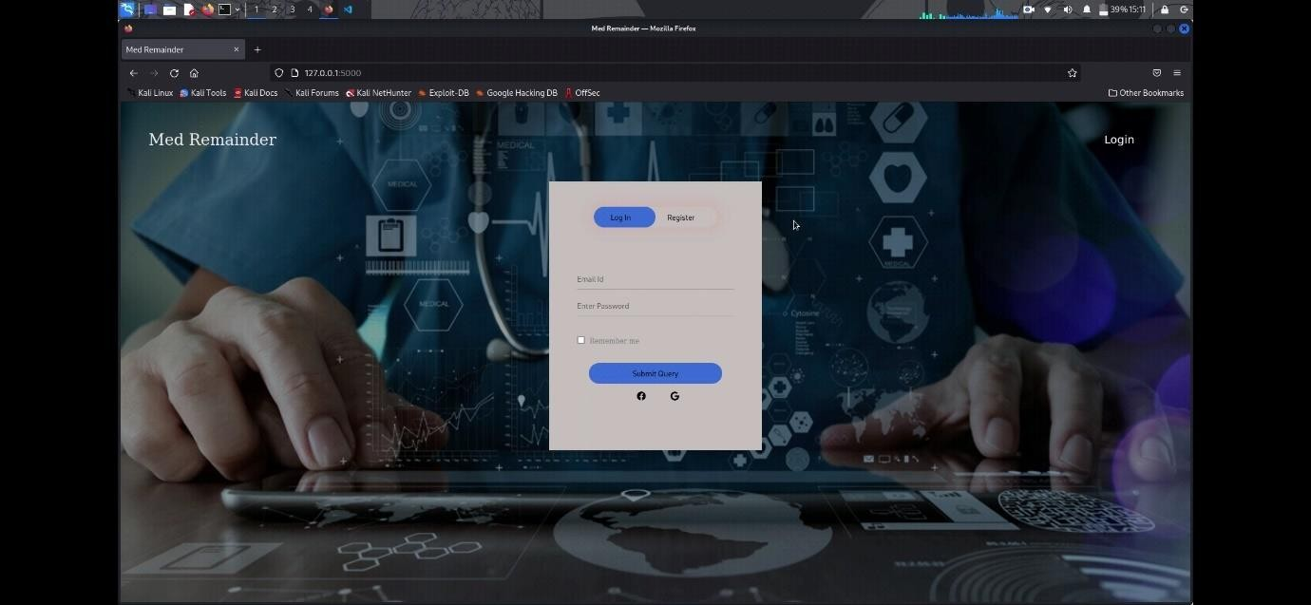

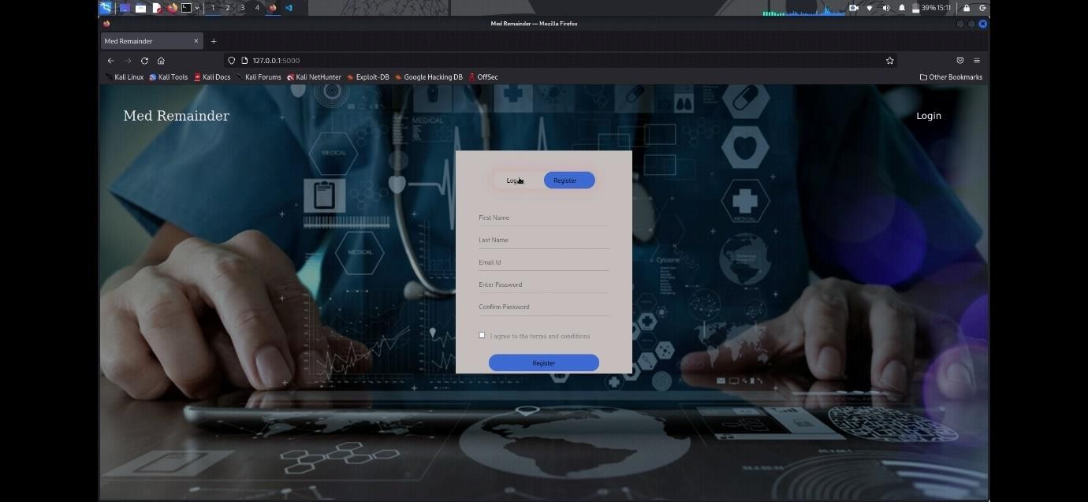

# DASHBOARD

<!doctype html>

<html lang="en">

<head>

<meta charset="utf-8">

<meta name="viewport" content="width=device-width, initial-scale=1">

<link href=["https://cdn.jsdelivr.net/npm/bootstrap@5.1.3/dist/css/bootstrap.min.css"](https://cdn.jsdelivr.net/npm/bootstrap%405.1.3/dist/css/bootstrap.min.css) rel="stylesheet"

integrity="sha384- 1BmE4kWBq78iYhFldvKuhfTAU6auU8tT94WrHftjDbrCEXSU1oBoqyl2QvZ6jIW3" crossorigin="anonymous">

<link rel="stylesheet" href="{{url_for('static', filename='css/style.css')}}">

<title>News Website</title>

</head>

<body class="m-0 p-0">

<h2>LOGED IN SUCCESSFULLY</h2>

</body>

</html>